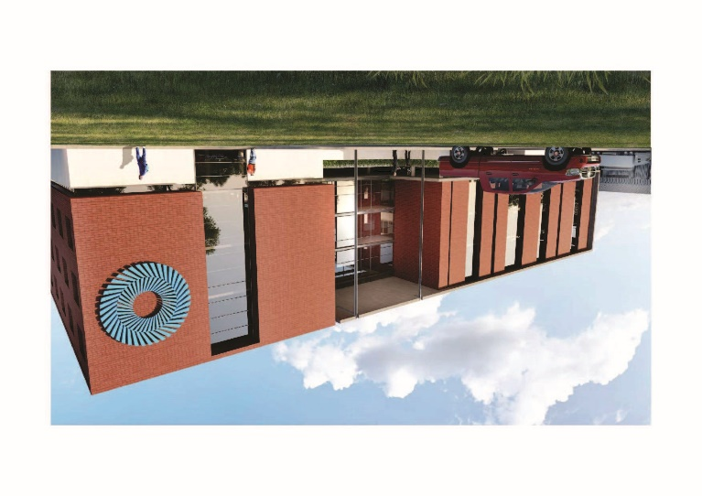

Salt River Depot

**RAILWAY- DEPOT’S**

The depots were very complicated

and were to accommodate existing

old coaches and also brand new

rolling stock that will be phased in

over the next ten years. Wheel

Lathes, running & lifting sheds

needed to be upgraded to suit test

pits, lifting jacks, in-floor lifting

systems, hoists & overhead cranes

for the new rolling stock it needs to

receive. New admin buildings were

also added for new staff.The yards

needed to be redesigned for

drainage, perway & bulk earthworks

as the yards were more than 50

years old and was blocked and not

draining properly.

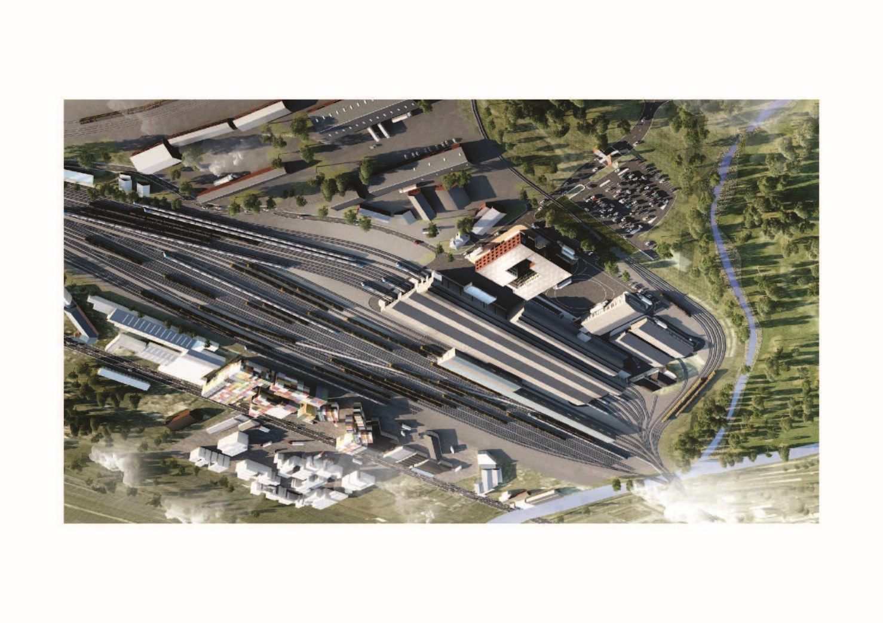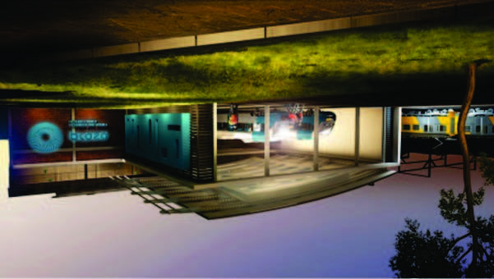

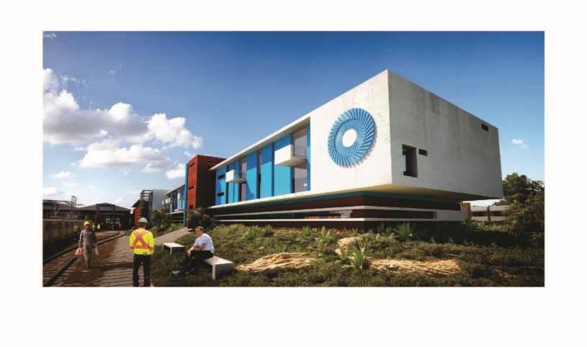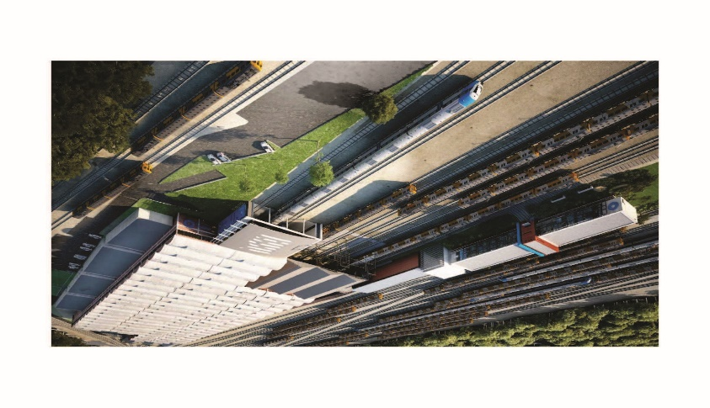

Braamfontein Depot

**SKY CITY MALL**