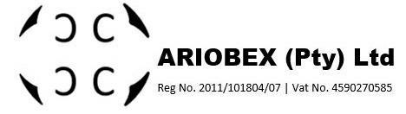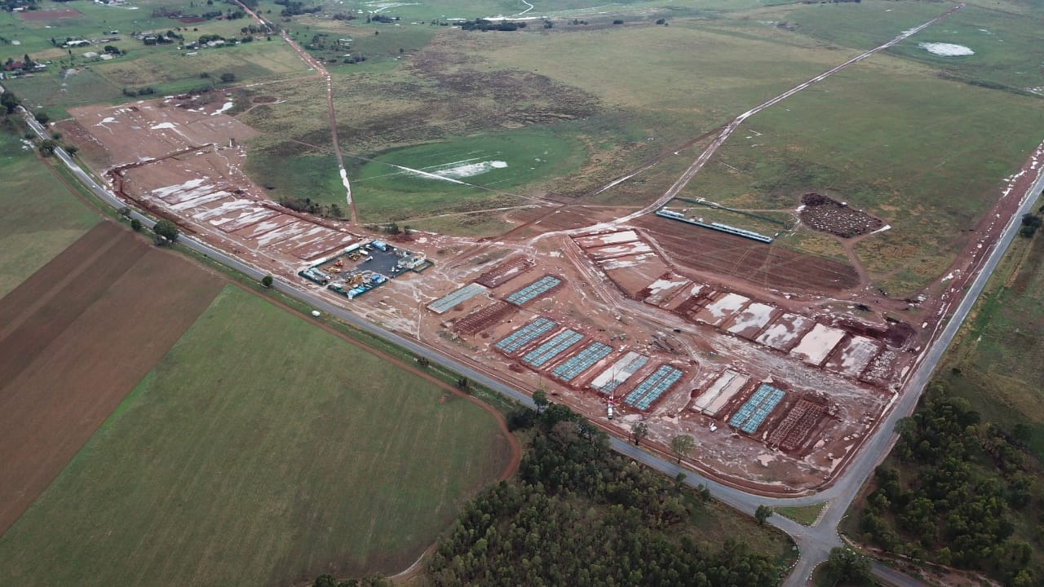

2268 Low cost housing units for Human Settlement. Our designs includes concrete raft foundations, loadbearing brickwork, precast slabs andinternal civil services, such as water networks, sewage reticulation, road & stormwater management.

**DAN TLOOME MEGA PROJECT**

Dan Tloome Mega Project

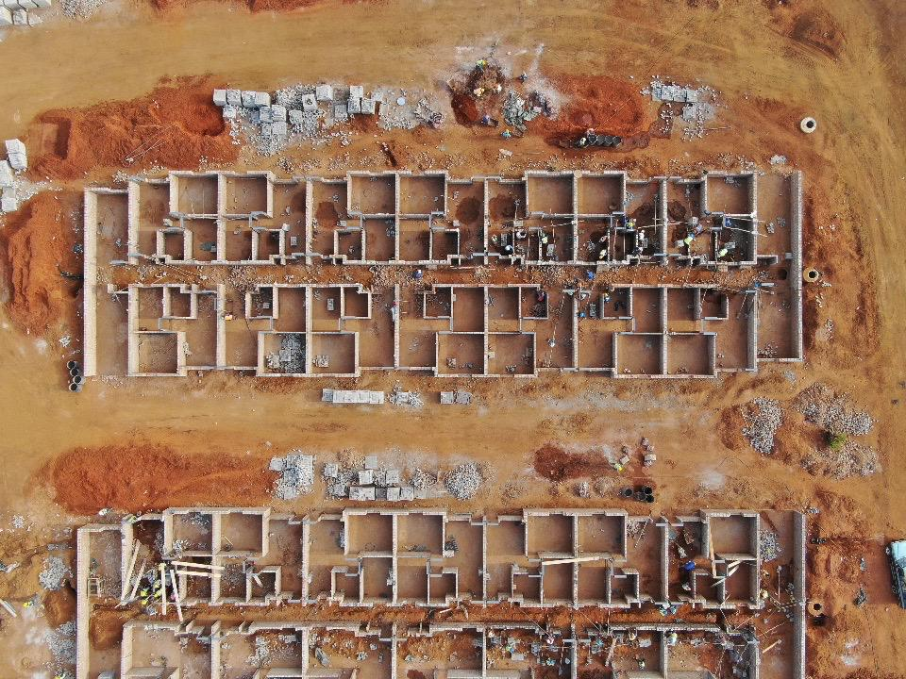

Dan Tloome Mega Project