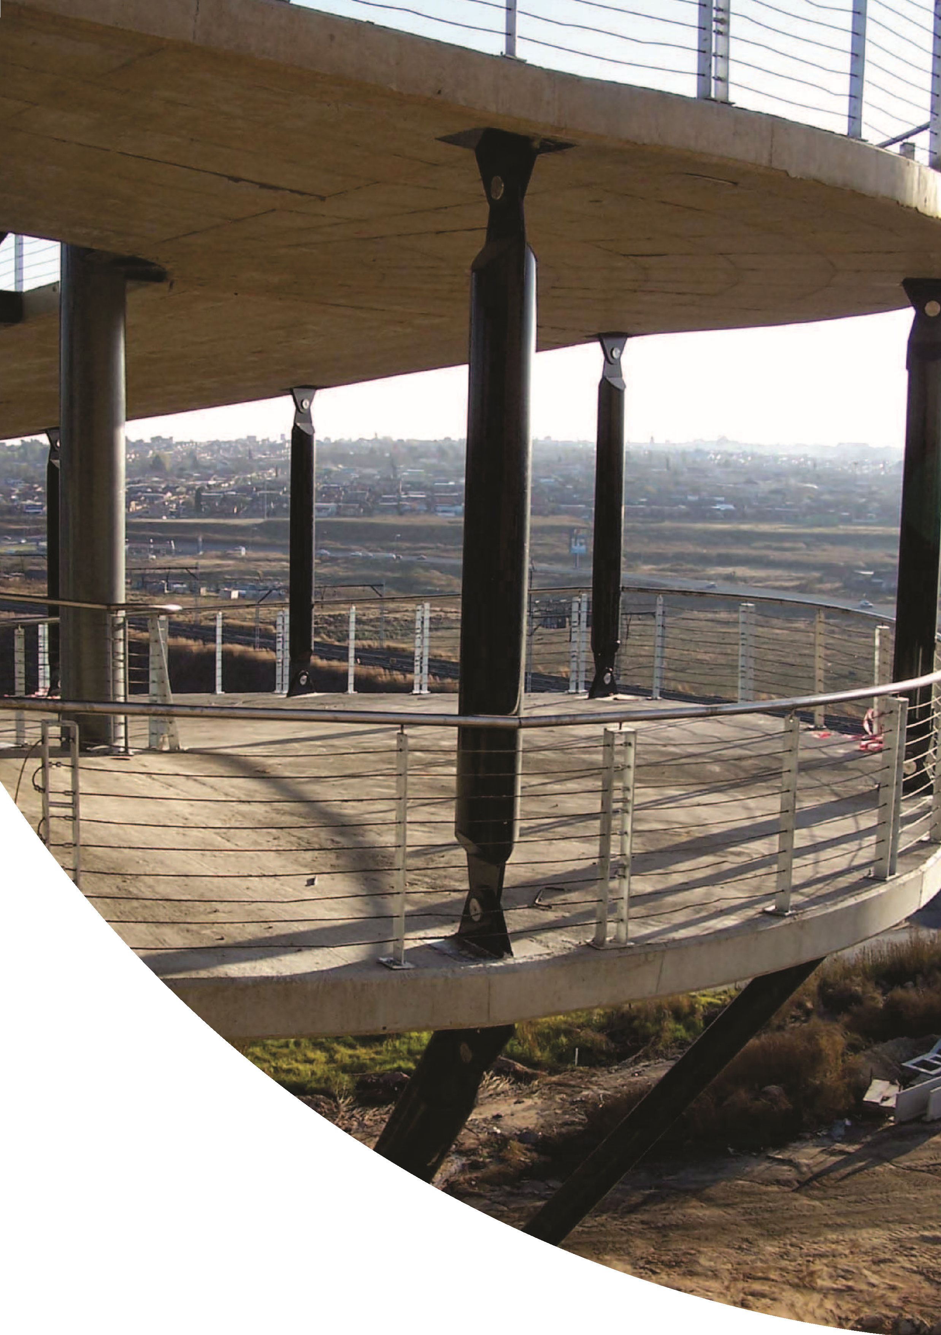
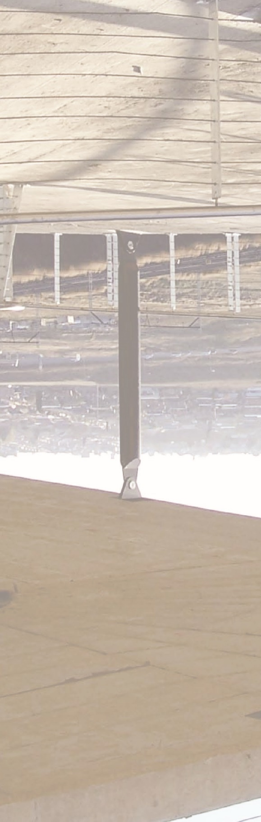
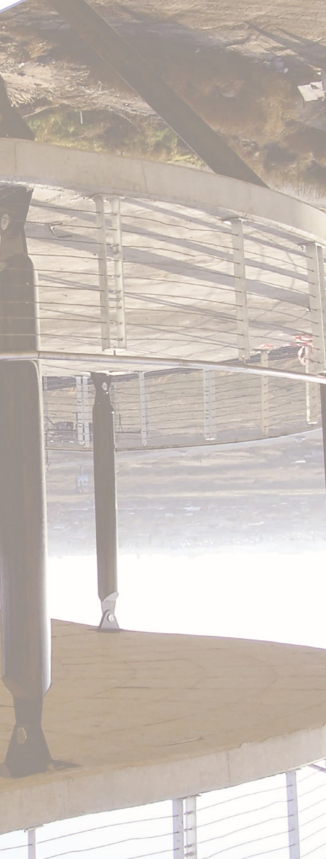
Company Profile
Proficient RAIL is a young leading
Engineering consultancy and highly
productive.
The company has grown into a highly
productive
organization
employing,
experienced and young,people with
good character and judgment.
Specialist divisions within the
Company are:
Railways,Depot's,Stations & Bridge
Inspections (Railway related projects)
Mining Rehabilitation works(checking
&rehabilitation of existing plants)
&
Commercial
Buildings
Industrial
Structures
(
Steelwork,
in-situ
and
Precast concrete & rebar)
Infrastructure & Civil Services (Civil
Services–water,sewer,stormwater&
roads)
Sports Stadia & Leisure (Stadiums &
swimming pools)
Road Traffic & Transportation (Roads,
entrances & traffic impact studies)
Clients of the company include many national and
regional organizations, government institutions, private
industrial and commercial concerns, multi-national
companies and numerous major private clients.
The Company provides clients with a totally integrated
Design & Project Management services a cross a wide
range of engineering disciplines.
The Company has been at the forefront of engineering
technology with its designs, its expertise in fast-track
construction techniques, and its many high quality
economical designs with low maintenance costs &
flexibility for future change.
Many of our projects have been completed in the
Gauteng area and other projects spread across South
Africa.
Our experience and expert knowledge in structures have
resulted into having the knowledge to solve special
problems and to apply certain techniques during design
and construction, to finish them on time.
In recent years many of our projects required a
comprehensive consulting service ranging from design,
Site investigations,site supervision during construction,
and project management. We have been involved from
the first stages of foundation design,to completing the
structure.Sites with problem soils are increasingly being
used for development because most of the good sites
have been developed already.With our extensive
knowledge of modern ground treatment techniques we
have been involved in the assessment and development
of a variety of such sites.
services
a
for
We
have
provided
consulting
comprehensive range of projects for both public and
private sector clients as well as other engineering
consultants.These have included railways. Depot's,
stations,perway,offices,shopping centres,banks,
Industrial buildings and estates,hospitals,schools,hotels
township
and
residential
facilities,
leisure
and
developments.Detail design and project management
have been carried out, in association with other
consulting engineering firms, shown hereafter.
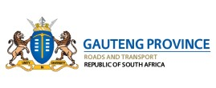
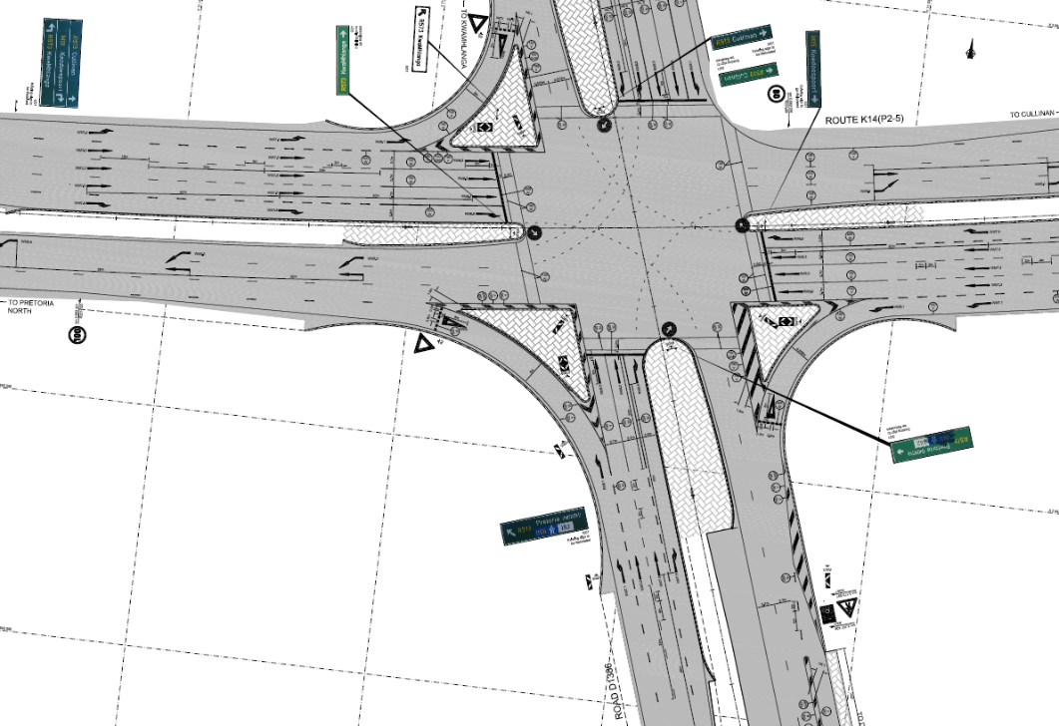
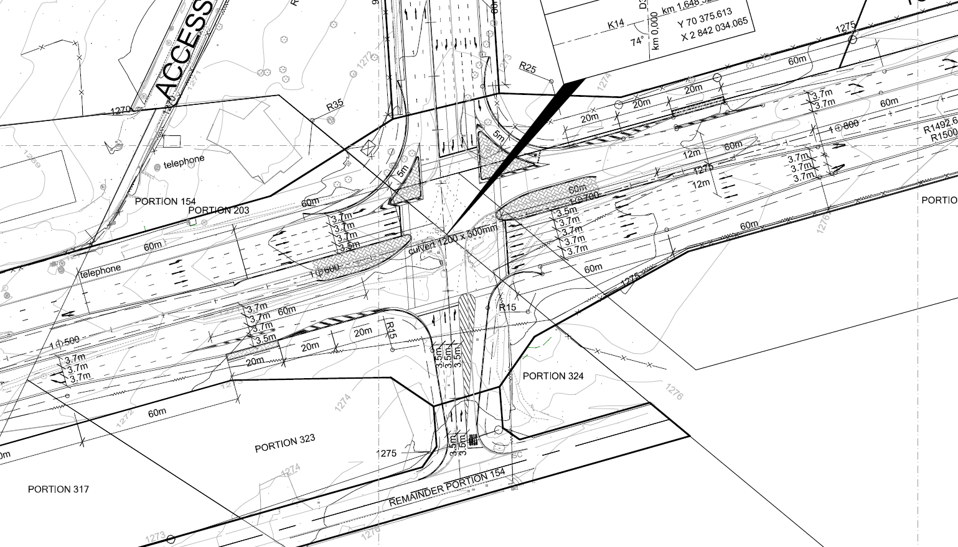
K14 ROAD UPGRADE
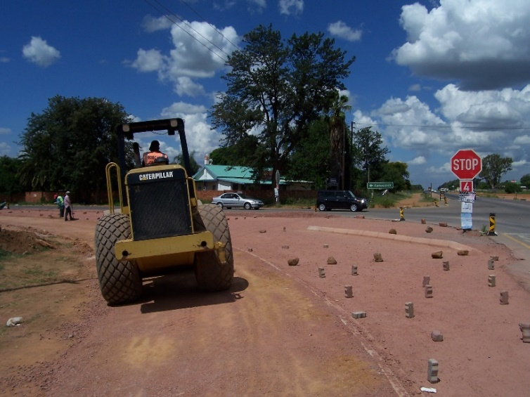
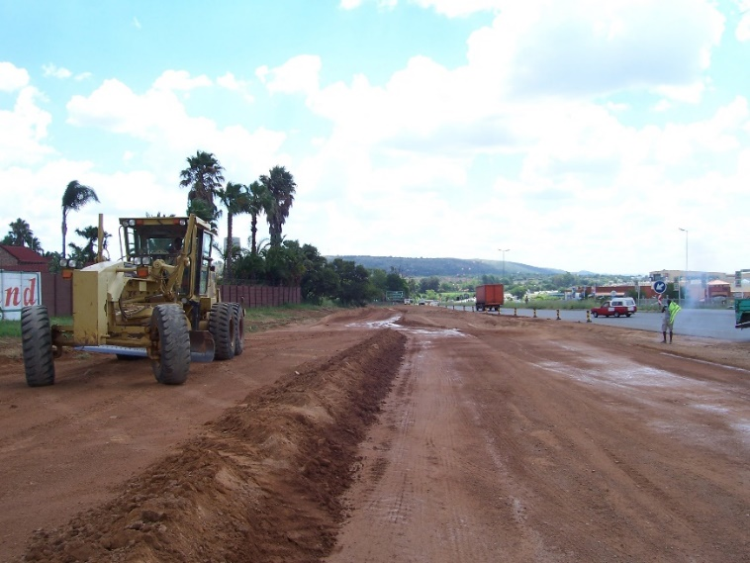
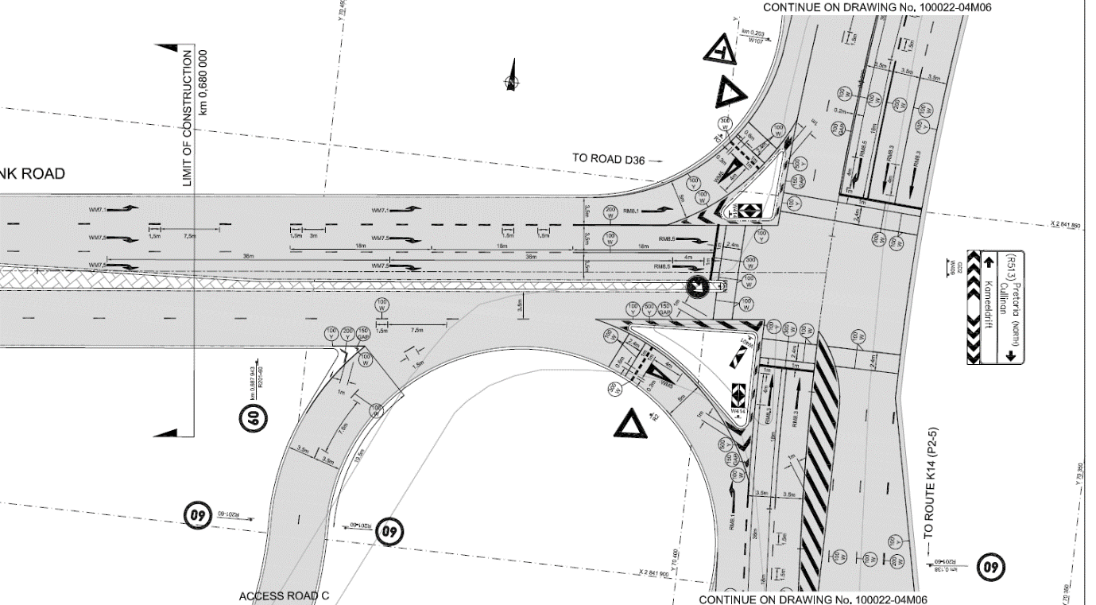
K14 ROAD UPGRADE
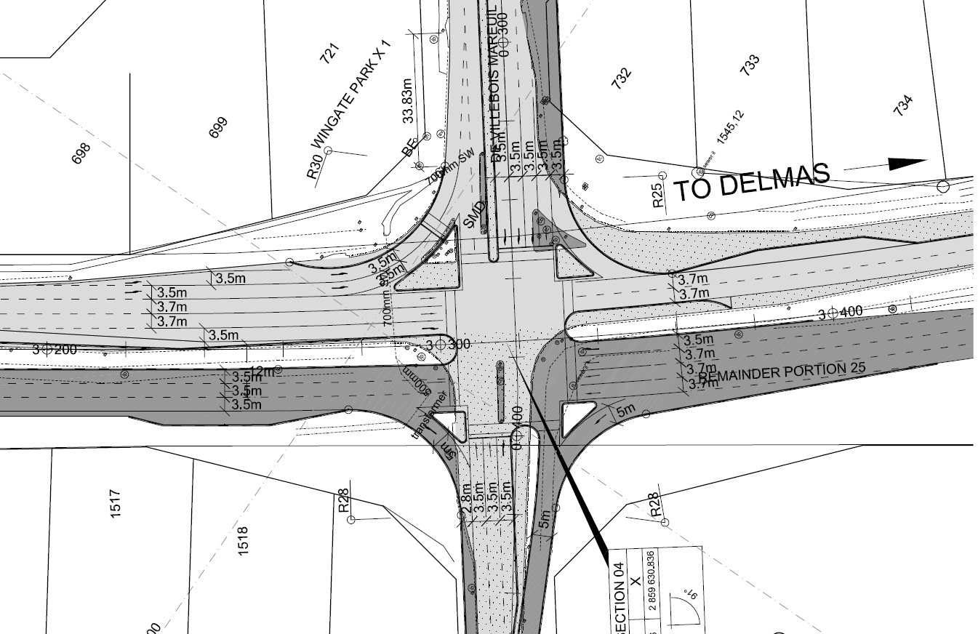
R50 INTERSECTION

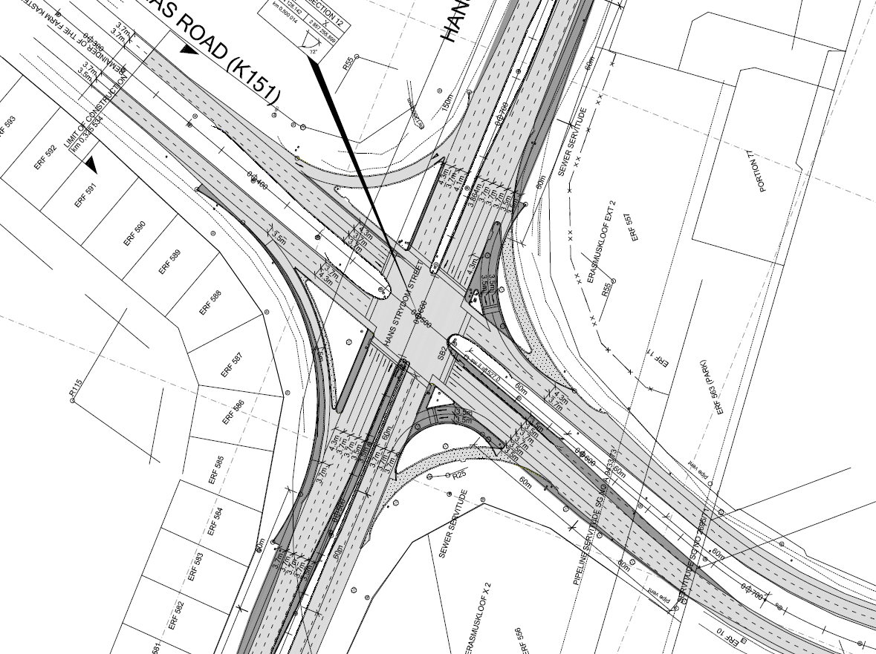
R50 INTERSECTION
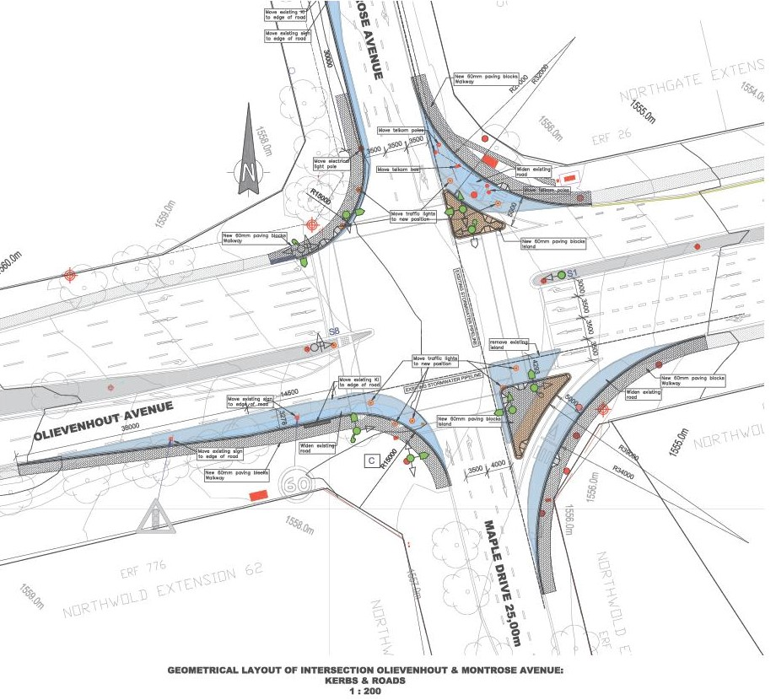
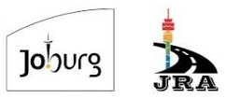
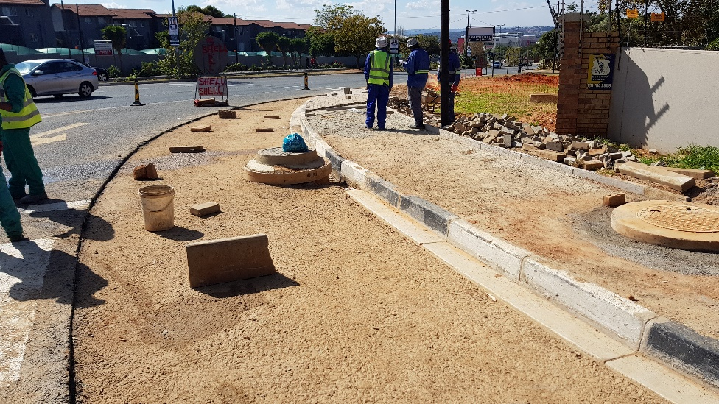
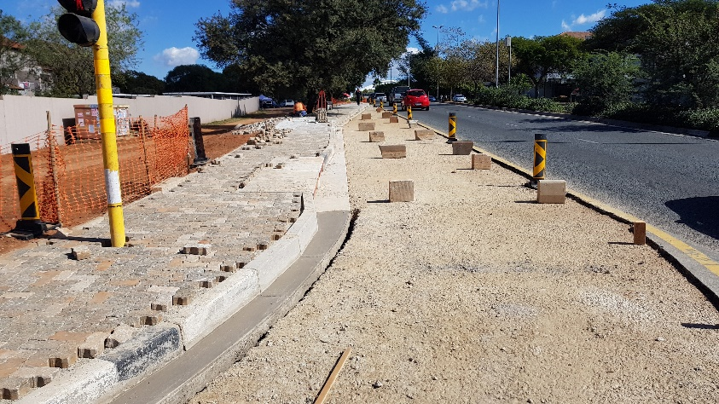
OLIEVENHOUT/MAPLE RD INTERSECTION
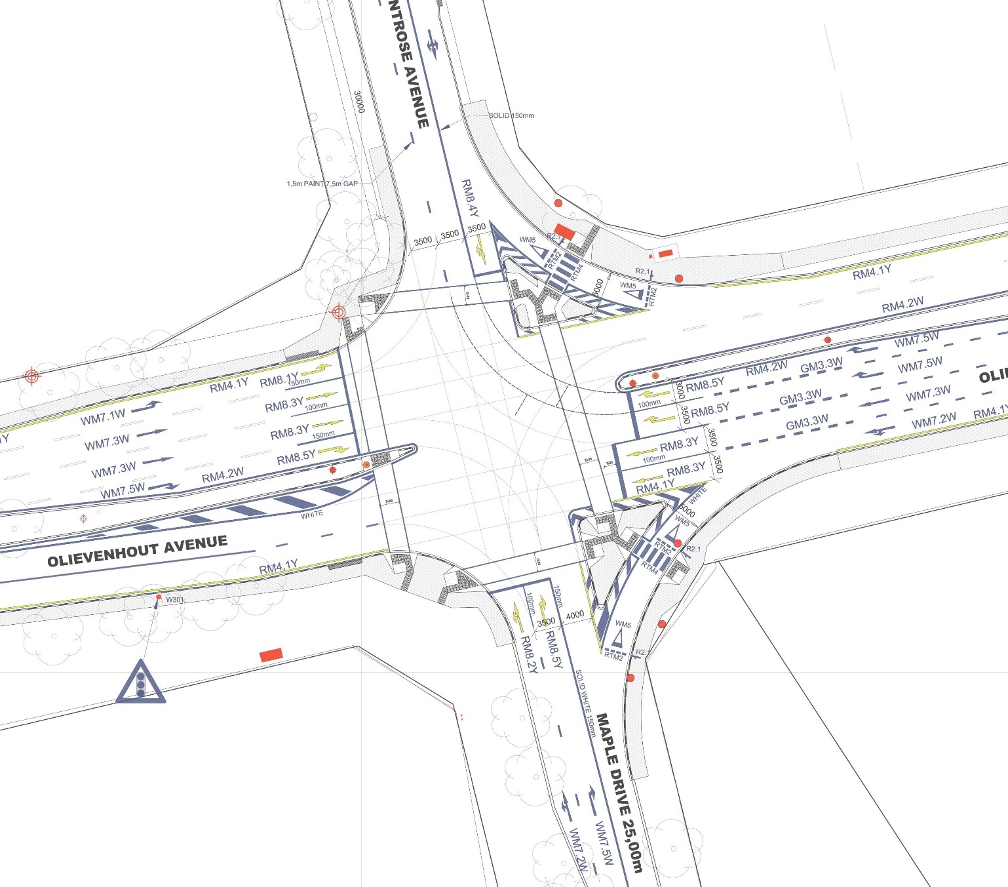
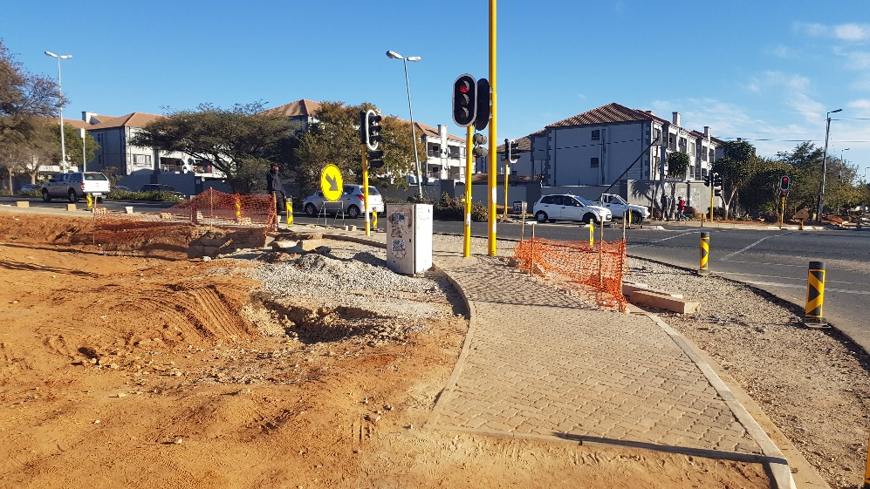
OLIEVENHOUT/MAPLE RD INTERSECTION
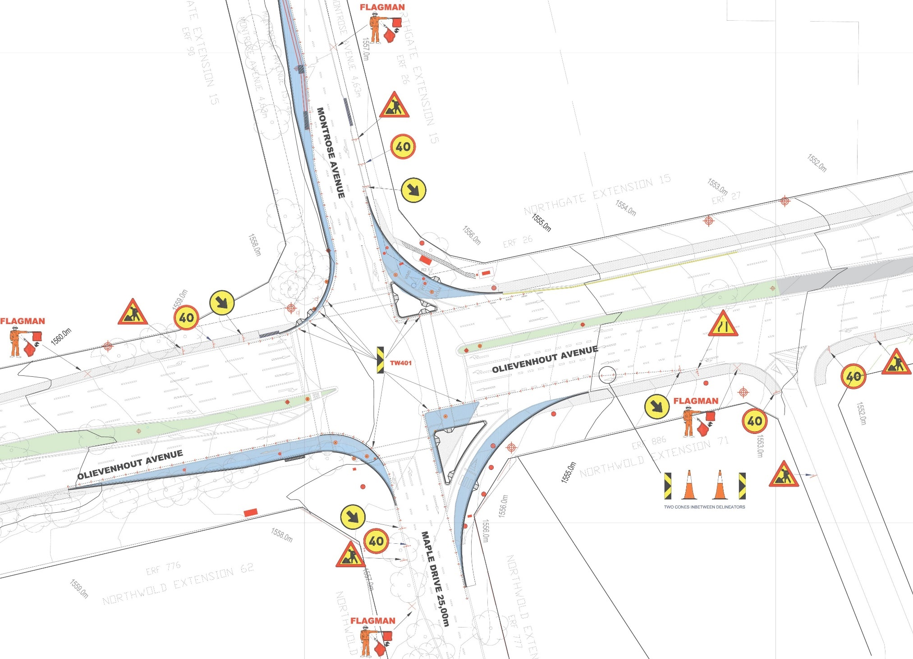
OLIEVENHOUT/MAPLE RD INTERSECTION
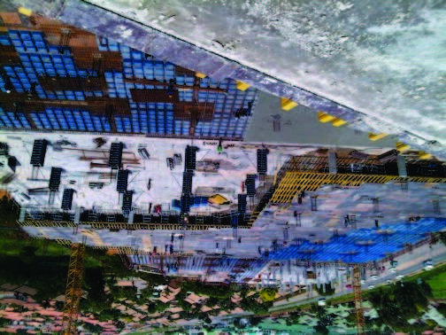
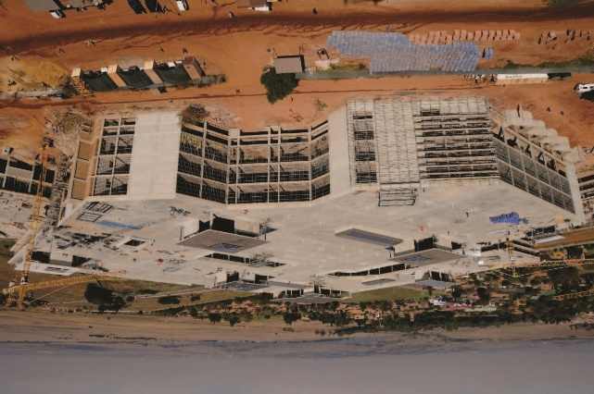
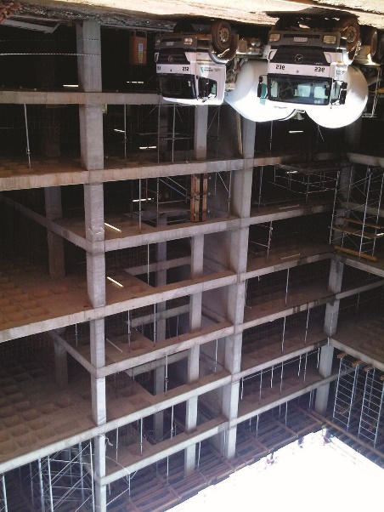

health & safety
1.
It is the policy of Proficient RAILto ensure so
far as reasonably practicable, the health,
safety and welfare of its employees at work.
2.
The Company and its employees are to
comply, as far as reasonably practicable, with
the requirements of the Health and SafetyAct
and with all its statutory provisions.All
employees are required to assist in achieving
this aim.
3.
Overall and primary responsibility for
maintaining a safe and healthy working
environment within Proficient RAIL, lies with
the Company owner.The onus of overall and
primary responsibility does not absolve
individuals from their specific responsibilities
under the Health and SafetyAct.
4.
Each and every employee is required, by the
Health and Safety at WorkAct, while at
work:
To take reasonable care for the health and
safety of themselves and of other persons
who may be affected by their acts or
omissions at work.
To co-operate with their Line Manager, or any
other person, so far as is necessary, to enable
them to comply with any health and safety
duty, or requirement placed upon them.
To avoid intentionally or recklessly interfering
with, or misusing anything provided in the
interests of health, safety or welfare.
5.
Where applicable, disciplinary action will be
taken where breaches of regulations and/or
wilful disregard of safety practices or
procedures occur.
6.
Training for these individuals, and other staff,
will be provided by the Company as required.
7.
All contractors or consultants working for
Proficient RAILwill be required to comply with
the Health and Safety Policy of the Company.

